Rooms are blocked from November 2 – November 12, 2023
Dance Academy of Loudoun Disney Trip

Walt Disney World Resort Accommodations

The Dance Academy of Loudoun has reserved a block of 40 rooms at Disney’s Port Orleans Riverside at Walt Disney World for the Disney Performing Arts Workshop. The rooms have been blocked for November 2nd to November 12^{h} to accommodate longer stays. 40 rooms have been held which is the maximum allowed per group and will be reserved on the first come, first serve basis.

Room Rate: $290 per night

Overview of Port Orleans Riverside:

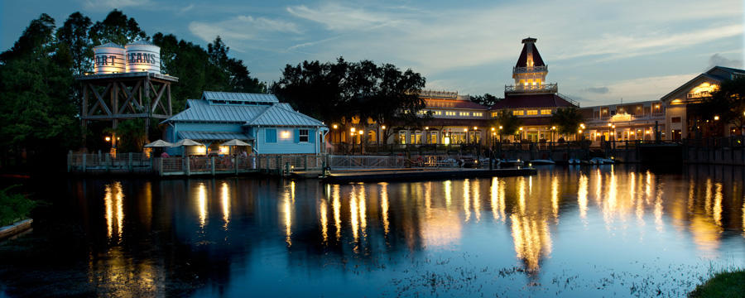
From the stately white-column mansions of Magnolia Bend to Alligator Bayou’s quaint backwoods cottages, delight in a picturesque setting that evokes the romance of rural Louisiana. Take a short walk along the Sassagoula River to Disney's Port Orleans Resort – French Quarter, known for Southern specialties like gumbo, jambalaya and beignets. Bus transportation provided to all four theme parks and boat transportation to the Disney Springs. Please note: These rooms sleep 4 people. If you have a family of 5; you will need 2 rooms or contact me for other options.

Reservations/Deposit:

To book your stay at this resort, a one night’s deposit is due by December 16th. To make the reservation, please drop off your deposit at the Dance Academy of Loudoun with the attached form. Checks should be made out to Dance Academy of Loudoun in the exact amount. In order to receive your room confirmation number; dates need to be firm by June 30th (there can be no changes to your dates after this point).

Final payment will be due by August 15th.

If you have any questions or would like to inquire about staying at another Disney World Resort for your trip, please feel free to contact me at (410) 952-0800 or at NicoleSutton@glassslipperconcierge.com

Have a magical day!

Nicole Sutton
Disney Vacation Planner
Glass Slipper Concierge

